- Your friend (and his lab partners) are having trouble graphing their data. All three partners used the same raw numbers but each made a graph that looks completely different from the graphs made by the other two. (Of course they also can’t remember which assay the numbers came from!) Study the graphs below and provide an explanation for how these three graphs could look so completely different. Be sure to state which assay the raw numbers likely came from. (10 points total)

absorbance

absorbance

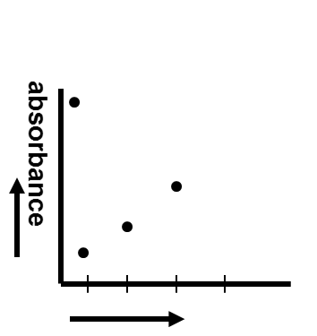
2 Draw a quick sketch of the following 2 graphs. Be sure to label the axes appropriately but there is no need to label every data point since we are looking for trends in the data. Make your sketch clear and easy to read. In just a few sentences, describe why each graph appears as it does. (5 points each for 10 total)
a. Product vs. Time Course for a reaction in which you used half the amount of enzyme in all of the tubes, but left the other parameters unchanged

b. Product vs. pH if you test pH 1, pH 2, pH 3 and pH 4 with the same acid Phosphatase you used in the Enzyme I & II experiments.

